The International Police Association-Section of Montenegro, European Network Policewomen and the Association of Policewomen of Montenegro invite you to the Global Conference on Gender Equality in the Police, which will be held in Montenegro, at Splendid Hotel in Budva, from March 25 to 28, 2024.
Each delegation is obliged to prepare a presentation, lasting up to 10 minutes, which will contain the measures you apply in your police forces in order to improve the situation in the field of gender equality. The three best presentations (which contain positive measures that are applicable in other countries) will be awarded.
The invitation applies to men and women, because gender equality is important for both sexes and because together we can do more.
The price of the arrangement per person is 190 EUR in a double room and 319 EUR in a single room. The package price includes:
-3 half board (breakfast and dinner) and local taxes
-3 drinks of domestic production at the final festive dinner.
After the conference, a sightseeing tour will be organized for all participants (St. Stefan and Kotor).
Guests who want to stay longer in the hotel pay an additional 55 EUR per day and a tax of 1.5 EUR in a double room and 98 EUR and a tax of 1.5 EUR in a single room.
Seat reservations are made by paying the price of the arrangement, your link with instructions for foreign currency payment: https://secure.phobs.net/booking.php?company_id=ca00f0f0f9a1cfc24d756db197ccf760&partners_access=IPA
The application deadline is the end of February.
For additional information, you can contact ljiljanab73@yahoo.com

Hotel Splendid
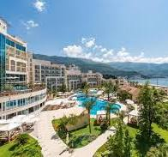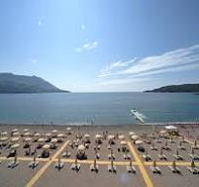
Kotor Sveti Stefan
